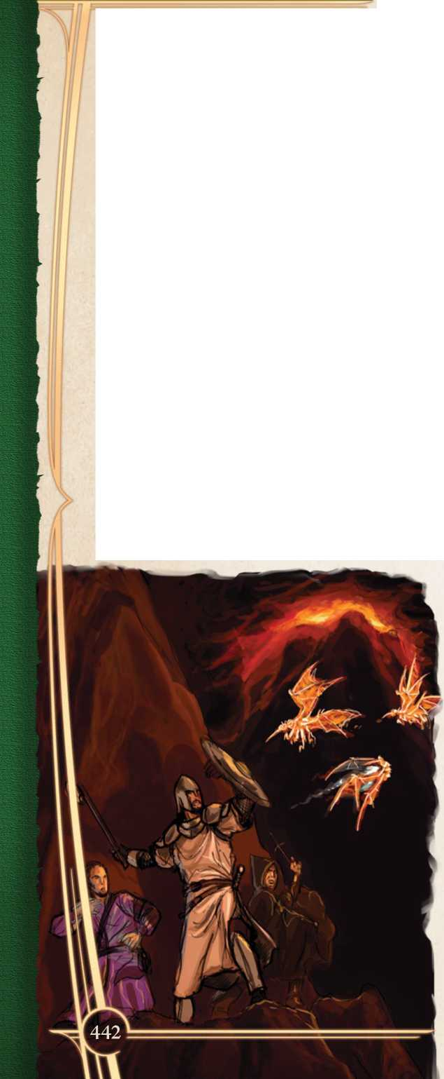Actions in Combat

On your turn, you typically have an action, a bonus action, and your movement. You can use one of the following actions, an action gained from your class, magic item, or trait, or an action that you improvise. Monsters have their own action options in their statistics.

When you want to perform an action not detailed here, the Narrator determines whether the action is possible and what kind of roll you need to make to determine if you succeed or fail.

Attack

Making an attack can be anything from swinging a sword, firing an arrow, or punching or kicking. Attacks are either melee attacks or ranged attacks. See the “Making an Attack” section for the rules that govern attacks. In addition to regular attacks, you may choose to use a special melee attack such as a shove, a disarm, or a grapple. These special melee attacks are described later in this chapter.

Certain class and monster features, like Extra Attack or Multiattack, allow you to make more than one attack with a single action.

Cast a Spell

Many spells have a casting time of an action. Some, though, use a reaction, bonus action, minutes, or hours to cast. See Chapter 11: Spellcasting for the rules that govern spells.

Dash

When you take the Dash action, your Speed is doubled for the current turn. The increase applies after applying any modifiers. If your Speed is 30 feet, for instance, you can move up to 60 feet on your turn if you Dash. If your Speed is reduced to 15 feet, you can move up to 30 feet if you Dash.

Disengage

When you take the Disengage action, you take a defensive, guarded retreat and your movement does not provoke opportunity attacks during that turn.

Dodge

When you take the Dodge action, instead of attacking you focus on avoiding attacks. Until the start of your next turn, attacks against you are made with disad­vantage if you can see the attacker, and you make Dexterity saving throws with advantage. You cannot take the Dodge action when your Speed is reduced to 0.

Help

When you take the Help action, you aid another creature in completing a task. The creature you aid gains advantage on the next ability check it makes to perform the task you are helping with before the start of your next turn.

You can also help a friendly creature in attacking a creature. You must be able to target the creature with an attack, or otherwise threaten it. If your ally attacks the target before your next turn, its next attack roll against the target is made with advantage.

Hide

When you take the Hide action, you make a Dexterity (Stealth) opposed by the passive Percep­tion scores of creatures able to observe you. If you succeed, you gain the benefits described in the Unseen Attackers and Targets section later in this chapter.

Press the Attack

When you take the Attack action, you can use a bonus action to make your attacks with advantage. If you do so, until the beginning of your next turn all attacks against you are made with advantage. You may only Press the Attack when you do not have disadvantage on attacks.

When you Press the Attack, your target can use its reaction to Fall Back.

Ready

When you take the Ready action, you prepare an action to be used when a certain trigger comes to pass. You first choose a perceivable circumstance that will trigger your reaction. Then you choose an action you will take in response to that trigger (such as making an attack, or using Dash to move your speed). When the trigger occurs, you can use your reaction immediately after, or you can decide to ignore the trigger, wasting your readied action.

When you ready a spell, it must have a casting time of 1 action, and readying it counts as concen­trating on a spell. When you take the Ready action to cast a spell, you first cast it normally and then concentrate on the spell to be released when the trigger is met.

Search

When you take the Search action, you focus your attention on finding something. Without using the Search action, your passive Investigation and passive Perception scores determine whether you notice a hidden creature or object. Using the Search action gives you an additional chance. Depending on the nature of your search, the Narrator may call for a Wisdom (Perception) check or an Intelligence (Investigation) check.

Fall Back

Sprint

Whenever a creature within your reach takes the Press the Attack action, you can use your reaction to yield ground. You move backwards 5 feet, your attacker does not gain advantage against you from using Press the Attack, and you have disadvantage on attacks until the end of your next turn. As part of its action, your attacker can move into the space you vacated.

A creature using the Rage class feature cannot choose to Fall Back.

When you take the Sprint action, you focus all your effort on moving as fast as possible to the exclusion of everything else.

* You may not take any other actions, bonus actions, or reactions other than your move Speed for the turn.
* If you are unencumbered, your Speed is quadrupled for one turn; if you are encum­bered or wearing heavy armor, your Speed is tripled for one turn.
* You must Sprint in a straight line each turn, although you can change direction each time you Sprint.
* You may Sprint for a number of turns equal to your Constitution modifier. Each turn you Sprint after that, you make a Constitution (Athletics) check (DC 10 + 1 per previous check made in the last minute) or you suffer a level of fatigue from either tiredness or a minor sprain or injury. You recover fatigue suffered from sprinting one minute after you stop sprinting.
* You cannot Sprint if you are suffering from one or more levels of fatigue.
* Attacks against you are made with advantage until the start of your next turn.

Tumble

You can use an action or bonus action to Tumble through a hostile creature’s space by deftly diving or rolling past. Make a Dexterity saving throw against the target’s combat maneuver DC. On a success, you can move through the hostile creature’s space once this turn. If you have proficiency with Acrobatics, you gain an expertise die on the save (or you gain a 1d6 expertise die if you also have the tumbling specialty.) The creature can choose to just let you pass and no save is required.

If you are smaller than the target, you have advantage. If you are larger than the target, you have disadvantage (though if you are two or more sizes larger than the target, you can move through the hostile creature’s space without making a check). You still provoke opportunity attacks if you move beyond a creature’s reach.

Use a Basic Maneuver

You can always choose to Disarm, Grapple, Knock­down, Overrun, or Shove as a basic maneuver instead of making an attack. See Chapter 10: Combat Maneuvers for the rules that govern basic maneuvers.

Use a Combat Maneuver

Many combat maneuvers are used alongside making an attack, but some have their own action costs. See Chapter 10: Combat Maneuvers for the rules that govern combat maneuvers.

Use an Object

Normally, you use an object while performing another action, such as drawing a sword or an arrow as part of an attack. You are also able to interact with one object for free on your turn without spending an action. When an object otherwise requires your action for its use (like administering or drinking a potion), you take the Use an Object action, which can also be useful when you need to interact with more than one object on your turn.

Making an Attack

Attacks all follow a simple structure, whether it is a melee attack with a sword, a ranged attack with a bow, or a spell attack. If it ever needs to be deter­mined whether an action counts as an attack, it is an attack if you are making an attack roll.

1. **Select a Target:** Choose a target within your attack’s reach or range: a creature, an object, or a location in space. Generally, you must have line of sight and line of effect to attack a target, but that can vary (such as firing an arrow through a glass window, or swinging a sword at where you assume a hidden target is located).
2. **Apply Modifiers:** The Narrator determines whether the target has cover and if you have advantage or disadvantage on your attack roll. Certain abilities, spells, or effects can apply additional modifiers or expertise dice to your attack roll.
3. **Resolve the Attack:** You make your attack roll, rolling a d20 and applying your modifier with the bonuses or penalties from above. On a hit, you roll damage and apply any additional effects of the attack.

Attack Rolls

When you attack a target, the results of your attack roll determines if it hits or misses. An attack roll is a d20 roll plus the appropriate modifiers (usually proficiency bonus and either Strength or Dexterity modifiers). If the total of the roll plus modifiers equals or exceeds the target’s Armor Class (AC), the attack hits. Objects and monsters have their own AC scores, while a character’s AC is deter­mined by their armor, ability scores, features, traits, and magic items.

***Critical Hits and Fumbles.*** A natural 20 on an attack roll is a critical hit and is always successful. On the flip side, rolling a natural 1 on an attack roll is considered a critical fumble and always misses.

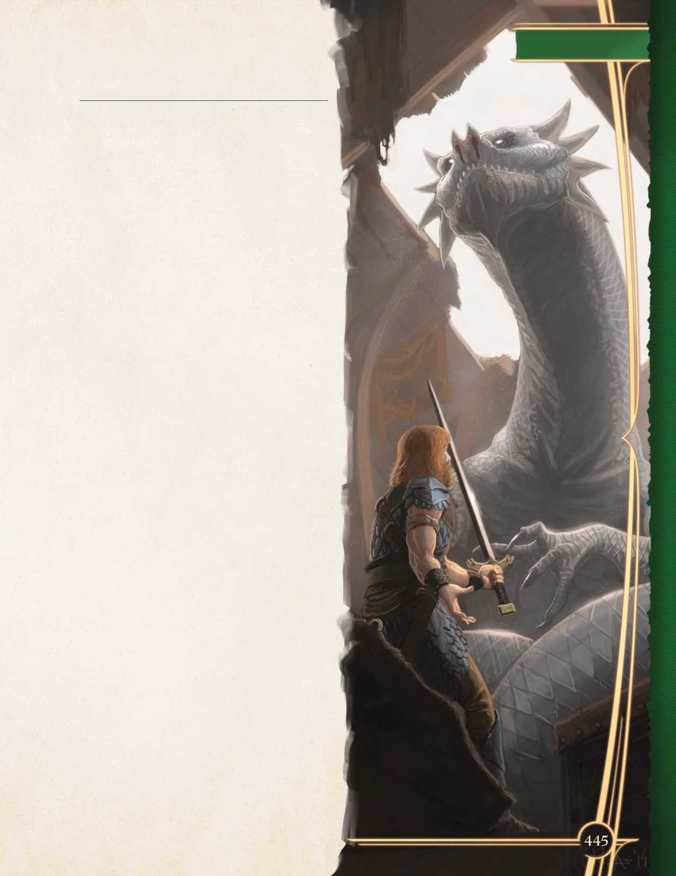

**Modifiers to the Roll**

When making an attack roll, a character typically adds an ability modifier and their proficiency bonus to the roll. Monsters and other NPCs use whatever modifier is provided in their statistics (though they typically follow the same formulas).

**Ability Modifier:** Melee attacks use the attacker’s Strength or Dexterity modifier depending on the weapon used, while ranged attacks usually use the attacker’s Dexterity modifier unless they are thrown.

Spell attacks utilize the spellcasting ability of the spellcaster, determined by the class or trait which grants the spell.

**Proficiency Bonus:** You add your proficiency bonus when attacking with a weapon you are proficient with, or when you are attacking with a spell. Nonproficient attacks do not add your proficiency bonus.

**Miscellaneous Modifiers:** Sometimes you will gain other modifiers to your roll. These can come from combat maneuvers, spells, features, traits, or any ability that adds an expertise die. Magical weapons also often grant bonuses to attack rolls.

**Unseen Attackers and Targets** Whether through stealth, environmental effects, or spells like *invisibility*, attackers and targets often go unseen. When you attack a target that you cannot see, but whose location you know, you have disad­vantage on your attack roll.

Being unseen does not always mean hidden; you may know the location of an invisible target that is not using the Hide action to move quietly. However, if a target is both unseen and undetected, you must guess what square it occupies, and the Narrator will typically say that an attack missed if you guessed wrong so as not to give more information about the target’s location.

Likewise, if your target cannot see you, you have advantage on your attack rolls against it. If you are hidden when you make your attack, you give away your location after making the attack.

In situations where your target is unseen by you and you are unseen by your target (such as if both

**Chapter 8: Combat**

you and your target are invisible, or if you are fighting in magical darkness), all attack rolls are made at disadvantage.

Some creatures and characters have additional senses, like blindsight, that allow them to sense targets without vision. A creature is only unseen to them if they are unable to perceive it.

Ranged Attacks

Ranged attacks can be many things, from projec­tile weapons like bows and crossbows, to thrown weapons like handaxes or javelins, or even the more exotic like ranged spell attacks or monstrous attacks such as acid spit or launched spikes.

Range

Ranged attacks come with a range, and your target must be within that range. If a ranged attack has a single range, you cannot make an attack at a target beyond that range. If a ranged attack has two ranges (a normal range and a long range), attacks made at targets further than the normal range are made at disadvantage, and targets beyond long range cannot be targeted.

Ranged Attacks in Close Combat

It is difficult to aim a ranged attack when a foe is next to you. When you make a ranged attack while you are within the reach of a hostile creature, you make the attack with disadvantage.

Melee Attacks

A melee attack is an attack made in hand-to-hand combat. These can be attacks with manufactured weapons, unarmed attacks, or natural weapons like claws, teeth, or horns. Some spells utilize melee attacks as well.

Most creatures have a reach of 5 feet, allowing them to make melee attacks against any creature within 5 feet of them. Larger creatures, or crea­tures using reach weapons, can have larger reach (noted in their attack entries).

Opportunity Attacks

The melee attack rolls you make are not the only times a character swings their weapon in a round. There are feints, parries, and other movements that are not rolled. As such, if someone drops their guard, they open themselves up to attack. Such an attack is called an opportunity attack.

You can use your reaction to attempt an oppor­tunity attack when a hostile creature that you can see moves out of your reach. An opportunity attack is a single melee attack against the provoking crea­ture made immediately before the creature leaves your reach.

The Disengage action can be used to avoid provoking opportunity attacks. Movement through teleportation does not provoke opportunity attacks, and unless noted otherwise neither does forced move­ment (such as if you are pushed away by a creature or effect, or if you move past a creature while falling).

Two-Weapon Fighting

When you take the Attack action and attack with a weapon that does not have the heavy property that you are wielding in one hand, you can use your bonus action to attack with a different dual-wielding melee weapon that you are holding in your off-hand. You do not add your ability modifier to the damage roll of the bonus attack, unless that modifier is negative. If a weapon has the thrown property, you can make a ranged weapon attack with it instead.

If you have the Extra Attack feature, you can use your bonus action to make two attacks with the weapon in your off-hand.

Damage and Recovery

Those who seek adventure do so knowing that they face the risk of injury and death. A fall onto sharpened stakes of a cunning pit trap, the scimitar swung recklessly by the dastardly pirate, a druid’s summoned lightning striking from a clear sky, or the deadly bite of a giant serpent—all can damage or kill even the mightiest of creatures.

Hit Points

Hit points represent a creature’s stamina, willpower, and the luck needed to survive deadly challenges. Creatures with a lot of hit points are harder to kill, while those with few hit points are more fragile.

A creature’s current hit points can be any number from their hit point maximum down to 0. A creature loses hit points when taking damage, subtracting the damage value from current hit points down to a minimum of 0, and regains hit points when it receives healing, adding hit points, up to its hit point maximum.

When a character loses hit points they aren’t necessarily taking physical harm, rather they are avoiding otherwise fatal blows, and their ability to keep doing so is whittled away as they take further damage and their hit points decrease.

Loss of hit points has no effect on a creature’s capabilities until it drops to 0 hit points.

Damage Rolls

Weapons, spells, and monster attacks specify the damage they deal. You roll the damage die or dice, add any modifiers, and apply the damage to your target. Magic, special abilities, and other factors can grant a bonus, or occasionally a penalty, to damage. With a penalty it is possible to deal 0 damage, but never negative damage.

When attacking with a **weapon**, you add your ability modifier (the same modifier used for the attack roll) to the damage. A **spell** tells you which dice to roll for damage and whether to add any modifiers.

Any time an effect deals damage to more than one target at the same time, roll the damage once for all targets. For example when a wizard casts *fireball*, the spell’s damage is rolled once for all creatures caught in its area of effect.

Critical Hits

When you score a critical hit, you double the attack’s damage against the target (including static modifiers). A critical hit can be turned into a regular hit by sacri­ficing an equipped shield (see Chapter 4: Equipment) or choosing to suffer fatigue (see Fatigue below).

Damage Types

Attacks, weapons, harmful spells, and other damaging effects deal different types of damage. Although damage types have no rules of their own, other rules (such as damage resistance) rely on damage types.

The damage types follow, with examples to aid a Narrator assigning a type of damage to a new effect.

***Acid.*** The caustic spray of a black dragon’s breath and the corrosive touch of an ooze deal acid damage.

***Bludgeoning.*** Blunt hits—punches, hammer­blows, and being crushed in a giant’s grip — deal bludgeoning damage.

***Cold.*** The numbing chill from a *ray of frost* and the frigid blast of a white dragon’s breath deal cold damage.

***Fire.*** A hot stove, a burning building, a conjured flame, and the inferno of a red dragon’s breath all deal fire damage.

***Force.*** Pure magical energy focused to strike at the enemy, force damage is supernatural and dealt mostly by spells (including *magic missile* and *spiritual weapon*).

***Lightning.*** The spark from a faulty gnomish gadget, a bolt of electricity striking from a storm, and a blue dragon’s breath deal lightning damage.

***Necrotic.*** The touch of a ghost withers flesh and wounds the soul. Necrotic damage is dealt by necromantic magic and the void of undeath.

***Piercing.*** Attacks that puncture and impale — arrows, daggers, spears, and monstrous bites with sharp teeth — deal piercing damage.

***Poison.*** Envenomed stings, bites and coated blades, toxic toadstools, and the noxious exha­lations of a green dragon deal poison damage.

***Psychic.*** Monsters with psionic powers and attacks on the mind itself by illusion or enchant­ment magic deal psychic damage.

***Radiant.*** An angel’s smiting weapon or a divine *guiding bolt* deal radiant damage, burning flesh and searing the spirit with raw power.

***Slashing.*** Cuts and swipes—whether from swords, axes, or monstrous talons — deal slashing damage.

***Thunder.*** The resonant power of the storm

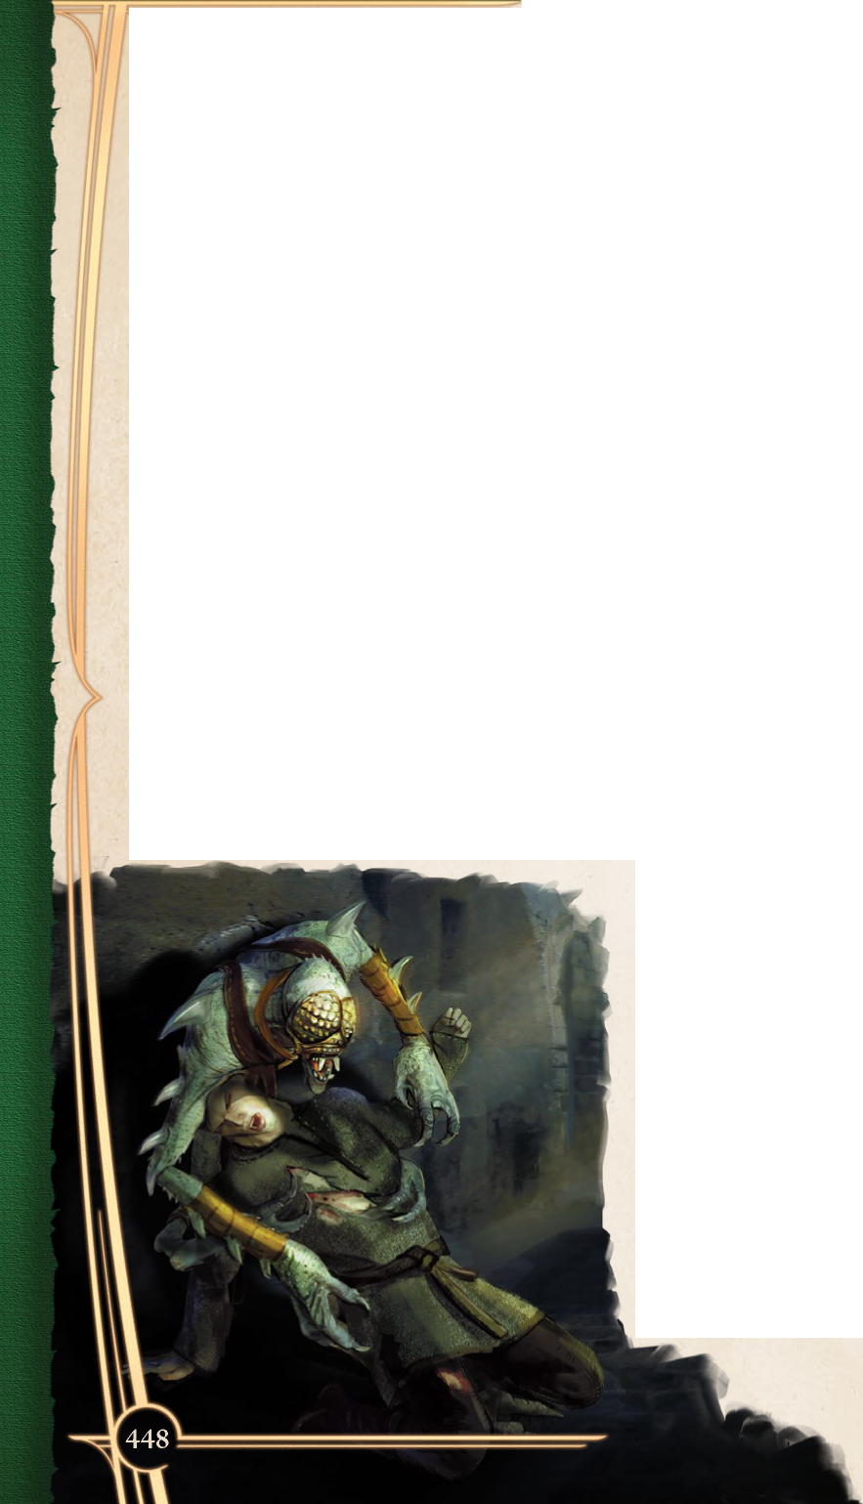and a concussive burst of sound, such as from the *thunderwave* spell, each deals thunder damage.

Ongoing Damage

Some attacks, spells, and effects deal **ongoing damage**. This hit point loss happens at the end of each of your turns. Unless the effect states a damage type, the hit point loss is unaffected by damage resistance or vulnerability (see below).

Ongoing damage could be caused by burning oil, a psychic echo, corrosive ooze, a bleeding wound, or another pernicious element.

An effect that deals ongoing damage specifies the circumstance that ends the damage.

For example, a **fire elemental**’s touch will cause its target to catch on fire. The burning creature takes 1d10 ongoing fire damage at the end of each of its turns until a creature uses an action to smother the flames.

Damage Resistance, Vulnerability and Immunity

Some creatures and objects are exceedingly diffi­cult or unusually easy to hurt with certain types of damage.

A creature or an object with **resistance** to a damage type takes only half the damage whenever it takes damage from that type.

A creature or an object with **vulnerability** to a damage type takes twice the damage whenever it takes damage from that type.

Resistance and then vulnerability are applied after all other modifiers to damage. For example, an **imp** is resistant to cold damage and is hit by a powerful *ray of frost* for 25 cold damage. The imp is also sitting in a magical cage which reduces all damage by 5. The 25 damage is first reduced by 5 and then halved, so the imp takes 10 cold damage.

Multiple instances of resistance or vulnerability affecting the same damage type count as only one instance. For example, if that imp with resistance to cold damage was additionally protected by a magical spell that granted resistance to all damage, the cold damage it takes is still only reduced by half (not reduced by three-quarters).

Some creatures and objects are **immune** to certain types of damage, or damage inflicted by mundane weapons. Damage immunity does not modify damage dealt; instead the immune creature is unaffected by damage of that type. Furthermore, some creatures are immune to certain conditions.

Fatigue, Death, and Doom

When you take damage you risk injury, uncon­sciousness, and death.

Massive Damage and Instant Death

Massive damage can injure or kill you instantly. If you are reduced to 0 hit points after taking an amount of damage equal to or greater than 20 + triple your character level (or Hit Dice for creatures), you make a DC 15 Constitution saving throw. On a failure, you die instantly, while on a successful result you live, but suffer one level of fatigue and one level of strife.

For example, an 8th level sorcerer with 25 hit points is subjected to a black dragon’s acid breath, taking 54 acid damage and being reduced to 0 hit points. Because they took massive damage (44



**Chapter 8: Combat**

Stabilizing a Creature

or more), the sorcerer must succeed on a DC 15 Constitution saving throw to avoid instant death.

If the sorcerer had succeeded on their saving throw against the breath weapon to take half as much damage, or if they had had resistance to acid damage, they would have only taken 27 acid damage, and although still reduced to 0 hit points wouldn’t have taken massive damage (and so isn’t at risk of instant death).

Dropping to 0 Hit Points

If damage reduces you to 0 hit points and fails to kill you, you are **unconscious** (see Appendix: Conditions page 616). This unconsciousness ends if you regain any hit points.

Falling unconscious during an encounter is trau­matic and inflicts a level of fatigue (see below).

Dying and Death Saving Throws

Whenever you start your turn with 0 hit points and you’re not **stable** (see below), you are dying and you must make a special saving throw called a death saving throw to determine whether you slip closer to death or cling to life. Unlike other saving throws, a death saving throw isn’t tied to an ability score, but can be affected by spells and features that modify your chances of succeeding on a saving throw.

Roll a d20. If the result is 10 or higher, you succeed. Otherwise, you fail. However, a single success or failure won’t spare or kill you. On your third success, you become stable. On your third failure, you die. These successes and failures don’t need to be consecutive—keep track of both until you collect three of a kind. The number of both is reset to zero when you regain any hit points or become stable.

***Rolling a 1 or 20.*** When you make a death saving throw and roll a natural 1, you suffer one level of fatigue and one level of strife. If you roll a natural 20, you regain 1 hit point, immediately regain consciousness, and are able to take the rest of your turn.

***Being Attacked at 0 Hit Points.*** If you take damage from an attack while you’re on 0 hit points, the attacker can choose to make you suffer a death saving throw failure, one level of fatigue, or one level of strife.

***Other Damage at 0 Hit Points.*** If you take any other damage while you have 0 hit points, you suffer a death saving throw failure. At the Narrator’s discretion, depending on the nature of the damage, such as blasting steam or errant magic, this may instead inflict a level of fatigue or strife.

Healing a creature on 0 hit points is the best way to save it. Where healing is unavailable, the crea­ture can be stabilized so that it doesn’t die due to failed death saving throws.

As an action, you can administer first aid to an unconscious creature to attempt to stabilize them, with a successful DC 10 Wisdom (Medicine) check.

A **stable** creature doesn’t make death saving throws, even though it has 0 hit points, but it does remain unconscious. The creature stops being stable, and must start making death saving throws again if it takes any damage. A stable creature that isn’t healed regains 1 hit point after 1d4 hours.

Fatigue

Sometimes during an encounter, a creature will gain an injury representing a serious wound. This is represented by fatigue.

***Suffering Fatigue.*** You gain a level of fatigue when:

* You take damage that makes you fall uncon­scious once or more during an encounter.
* You take a critical hit while at 0 hit points.
* When you take a critical hit, you can use your reaction to block it, turning the critical hit into a regular hit and suffering a level of fatigue (if you have a shield, you can Sacri­fice Shield instead; see page 318 in Chapter 4: Equipment).

The effects of fatigue gained during combat are only felt after the encounter in which they were inflicted has ended. During the heat of battle it is easy to fight on without realizing the extent of your injuries.

A creature can survive multiple such injuries and continue adventuring; however injuries are not to be ignored lightly. If you gain 5 levels of fatigue, you are **doomed** to die (see below), as your combined injuries mean you’re beyond the aid of all but the most powerful healing magics.

Doomed

A **doomed** creature has sustained damage to their body, mind, and spirit that puts it beyond the help of normal recovery and lesser magic. While the symptoms of a doomed creature’s injuries might be removed, only powerful spells such as *regeneration* or *resurrection* can spare it from death or restore it to life.

Suffering the effects of 5 or more levels of fatigue is one way to become doomed; however at the Narra­tor’s discretion a creature might become doomed for any number of other reasons.

Monsters, NPCs, and Death

Rather than falling unconscious, accruing injuries, or making death saving throws, a monster that drops to 0 hit points usually dies immediately.

Essential villains and important nonplayer char­acters are common exceptions. The Narrator might have any nonplayer character follow the same rules as player characters, or they might become **doomed** the moment they hit 0 hit points — allowing them a final dramatic action or speech before they succumb and die.

Knocking a Creature Out

Rather than killing, sometimes an attacker wants to incapacitate their foe, perhaps because they’ve sworn not to kill or simply to interrogate the enemy for information. When an attacker reduces a creature to 0 hit points with a melee attack, the attacker can knock the creature out. This choice is made the instant the damage is dealt. The creature falls unconscious, gains a level of fatigue, and is stable.

Healing and Recovery

Damage which doesn’t kill you isn’t permanent, and even death can be reversed with powerful magic. Rest can restore a creature’s hit points, and magical means such as *cure wounds* and a *potion of healing* can remove damage in an instant.

Any time a creature receives healing, hit points regained are added to their current hit points. A creature’s hit points can’t exceed their hit point maximum, so hit points regained in excess of this number have no effect. For example, a cleric casts *cure wounds* to heal a ranger 6 hit points. If the ranger has 10 current hit points and a maximum of 13 hit points, they regain 3 hit points to their maximum (not 6).

A creature that has died can’t regain hit points until magic such as the *revivify* spell has restored them to life.

Recovering From Fatigue

Recovering from fatigue is more difficult than restoring hit points.

A creature can recover from the initial level of fatigue during a long rest anywhere, but recovering from two or more levels of fatigue requires long rests taken at a Haven (Chapter 5: Exploration in *Trials & Treasures),* reducing its level of fatigue by one each time.

Temporary Hit Points

Some spells and special abilities confer temporary hit points to a creature, a separately tracked buffer against damage.

When you have temporary hit points and take damage, the temporary hit points are lost first, and any leftover damage is then subtracted from your normal hit points. For example, if you have 5 temporary hit points and take 8 damage, you lose the temporary hit points and then take 3 damage.

Healing can’t restore temporary hit points because they are separate from your actual hit points, however they can exceed your hit point maximum. A creature can be at full hit points and receive temporary hit points.

Temporary hit points can’t be added together—if you have temporary hit points and receive more of

them, you decide whether to keep the temporary hit points you have or gain the new temporary hit points. For example, if a spell grants you 10 temporary hit points when you already have 5, you can have either 10 or 5 (not 15).

**Chapter 8: Combat**

If you have 0 hit points, receiving temporary hit points doesn’t restore you to consciousness or make you stable. They still absorb damage directed at you while you’re in that state, but only true healing can save you.

Unless a feature that grants temporary hit points has a duration, they last until they’re depleted or you finish a long rest.

World Bonuses, Penalties, and Cover

The action hardly happens in a featureless void. Craggy roads, chandeliers of suspect quality, and figures reaching out from the mists for fresh blood can all greatly shape the way you move through the world.

World benefits and world penalties are objects, obstacles, and field conditions in the immediate area. They might provide you with bonuses, or can slow you down and provide another source of danger.

One of the most common forms of world penalties is difficult terrain. Anything from dense bramble, precarious steps, or tenacious mud can slow you down from your normal movement speed.

Difficult Terrain

Every foot of movement you take within difficult terrain costs 1 extra foot. Multiple hazards that would cause difficult terrain in a space do not stack. However, additional conditions that increase the cost of movement (such as crawling while prone) stack with difficult terrain.

A common world benefit presents cover for partic­ipants that stumble on it. Larger obstacles such as trees and stone walls can help to keep creatures out of sight and out of harm’s way.

Cover

Cover provides you with protection from attacks and effects that originate on the other side of it. There are three degrees of cover: half, three-quar-

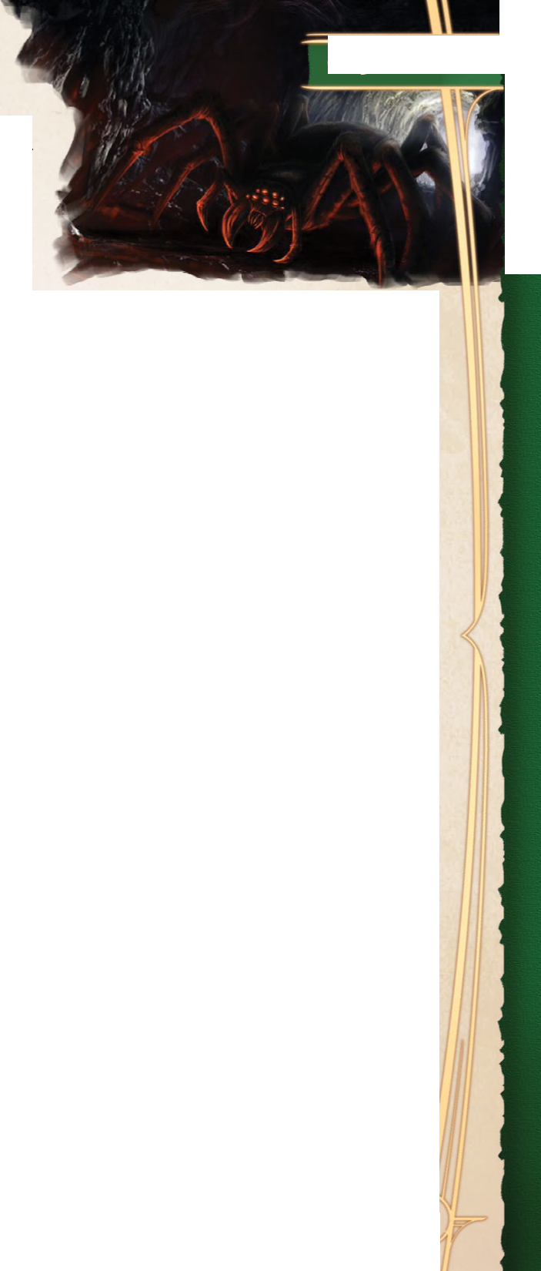ters, and total cover. If you are behind multiple sources of cover, you only gain the benefits from the most protective source of cover.

**World Actions**

**Example Environments**

**Half cover** is provided by obstacles that block at least half of your body, such as a tree trunk or another creature. Half cover provides you with a +2 bonus to AC, saving throws, and ability checks made to hide.

**Three-quarters cover** obscures three-quarters of your body, like an arrow slit or a castle wall. It provides you with a +5 bonus to AC, saving throws, and ability checks made to hide.

**Total cover** keeps you completely concealed from the other side. You cannot be targeted directly by attacks, spells, or ability checks, although spells that target an area of effect and checks to search the area might still reach you.

Environments are often dynamic spaces with moving parts other than their inhabitants. Within Turn-Based Action, the world gets its own turn to enact these moving parts in the form of a world action.

World actions have a variety of specific effects depending on the environment. A bolt of lightning might strike near a single participant. The fumes from the swamp could thicken and choke the people in it. New participants might even emerge from the landscape and jump right into the action!

If a particular bonus, penalty, or action doesn’t make sense for where the participants are located, the Narrator can reskin a different environment’s effects or forgo using them altogether for a Turn­Based Action encounter. That said, an unexpected effect can prompt creativity, challenge, and intrigue in the game.

CAVERNOUS

**LGUGL UP Adventurer’s Guide**

***Echo.*** Sound travels twice as far, and any effect which causes thunder damage does 1 extra point of damage per die rolled.

***Loose Foundation.*** Area hazard that can cause the entire section of cave to collapse within 2 rounds of being disturbed by any explosive effect or significant impact. Participants still in the area are grappled and start to suffocate (escape DC 12).

***Stalactites.*** Obstacles that can be knocked down by ranged attacks that deal any damage (AC 12). The creature beneath a stalactite makes a DC 12 Dexterity saving throw or takes 2d6 piercing damage.

***Stalagmites.*** Obstacles that each provide half cover.

FIERY

***Burning Surface.*** Touching an unattended object or a surface for the first time on a participant’s turn causes them to take 1d6 fire damage.

***Floating Ash.*** A participant that ends their turn in this area hazard makes a DC 10 Constitution saving throw or is blinded until the start of their next turn.

WORLD ACTIONS

***Flame Burst (Recharge 4-6).*** A single participant makes a DC 12 Dexterity saving throw or they take 1d12 fire damage.

***Sweltering Heat.*** All participants make a DC 10 Constitution saving throw or suffer one level of fatigue.

FORESTED

***Brush.*** Obstacle provides half cover while a participant is prone behind it.

***Trees (Fallen or Standing).*** Obstacle provides half cover.

***Fallen Leaves.*** Area hazard that may conceal potholes, traps, and other hazards. Participants can perceive what’s under the leaves by making a DC 12 Wisdom (Perception) check.

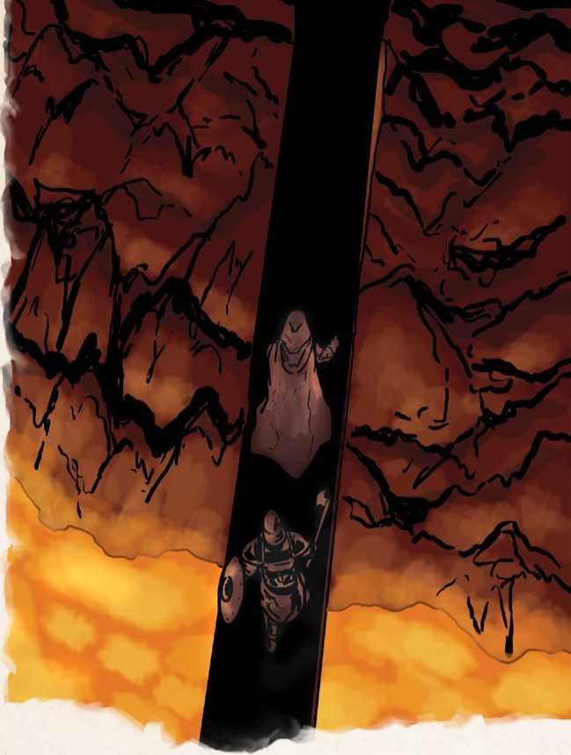WORLD ACTIONS

***Distressed Animal Cacophony (Recharge 4-6).*** All participants can only hear sounds within 10 feet of them (except for loud, explosive noises).

FRIGID

***Frostbitten Surface.*** Touching an unattended object or a surface for the first time on a participant’s turn causes them to take 1d6 cold damage. This effect is nullified if they have resistance to cold damage or the participant’s skin isn’t exposed to the surface.

***Icy Patch.*** When a participant starts moving in a single direction through this area hazard, move­ment in another direction is considered difficult terrain until the start of their next turn.

***Snow.*** The area is partially obscured.

WORLD ACTIONS

***Cold Chill (Recharge 4-6).*** All participants make a DC 15 Constitution saving throw or take 2d6 cold damage. This damage is reduced to 1d6 if they are wearing cold weather gear.

***Uneven Footing.*** Area hazard that counts as difficult terrain.

WORLD ACTIONS

***Falling Rocks (Recharge 5-6).*** Participants near

a treacherous cliffside make a DC 15 Dexterity saving throw or take 2d6 bludgeoning damage.

STORMY

***Heavy Precipitation.*** The area counts as difficult terrain.

***Loud Winds.*** All participants can only hear sounds within 15 feet of them (except for loud, explosive noises).

WORLD ACTIONS

***Forceful Gale.*** A single participant makes a DC 12

Strength saving throw or they are pushed 15 feet in one direction. This movement does not provoke opportunity attacks.

***Lightning Strike (Recharge 5-6).*** A single participant makes a DC 10 Dexterity saving throw or they take 4d6 lightning damage. They cannot be targeted by this action again until Turn-Based Action ends.

№

SWAMPY

***Thick Trudge.*** Area hazard that counts as diffi­cult terrain.

***Tenacious Mud.*** When a participant ends their turn in this area hazard, they make a DC 12 Strength saving throw or are restrained until the end of their next turn. They can use their action to break free of this effect.

WORLD ACTIONS

***Swamp Gas.*** Participants in mud make a DC 10 Constitution saving throw or are poisoned until the end of their next turn.

***Leeches (Recharge 6).*** A **swarm of insects** (leeches) rises out of the swamp to attack any creature in the marsh.

FURNISHED

***Chandelier.*** Obstacle can be swung from with a DC 12 Dexterity (Acrobatics) check, or knocked down dealing 2d6 bludgeoning damage to any creatures underneath (each makes a DC 12 Dexterity saving throw to negate the damage).

***Clutter.*** Area hazard that counts as difficult terrain. If a participant uses the Dash action to move through the area, they make a DC 10 Dexterity saving throw or fall prone.

***Mirror.*** A participant holding this object can use their reaction to reflect a 1st-level spell or cantrip targeting them, turning it back onto the spellcaster by succeeding on a Dexterity check opposed by a spellcasting ability check (on a failure, the spell hits a randomly determined unoccupied square). The mirror then breaks.

***Tables.*** Obstacles that can be pushed over as an action to provide half cover.

HAZY

***Blanketed Ground.*** Area hazard that may conceal potholes, traps, and other hazards. Participants can perceive what’s under the fog by making a DC 12 Wisdom (Perception) check.

***Thick Fog.*** The area is heavily obscured.

WORLD ACTIONS

***Shadow Puppet (Recharge 6).*** A **shadow** that looks identical to a random participant in the haze manifests and is hostile to everyone (initiative 20). The shadow can see through the fog clearly.

***Twisting Haze.*** All participants in the haze move into randomly determined unoccupied spaces within 5 feet.

ROCKY

***Boulder.*** Obstacle can be dislodged and made to roll with a DC 15 Strength (Athletics) check, dealing 2d10 bludgeoning damage to any creatures in its way (each makes a DC 12 Dexterity saving throw to negate the damage).

***Loose Rocks.*** Object can be used for a thrown weapon attack (1d4 bludgeoning, range 15/30 feet).

Controlling Summons and Multiple Creatures

The Narrator typically controls all characters that aren’t the PCs. However, players may command mounts and hirelings, summon familiars, or conjure squads of reinforcements to tip the scales of any Turn-Based Action encounter in their favor.

Any creatures or summons under your control can take their movement at any point on your turn. Identical creatures and summons move as a group provided each is adjacent to one other member.

You can use your bonus action to command a single creature or group of creatures to take their actions. For groups, this means each member performs the same action against the same target or towards the same goal.

**For group ability checks:**

**1.** Roll the ability check for one member of the group.

**2.** For Strength group ability checks, add +1 for every other member of the group.

**For group attack rolls:**

1. The attack roll becomes a Dexterity saving throw made by the target. If the attack is already based on a saving throw, skip step 2.
2. The DC of the Dexterity saving throw equals 8 + the highest attack bonus among creatures in the group. On a failure the target takes the attack's damage and any additional effects, or half damage and no additional effects on a success.
3. Add +1 to the DC and damage for every other member of the group.

Alternative Turn-based Action Scenarios

The Turn-Based Action rules can be used for more than combat and are also ideal for most high-octane situations. There are several alternative scenarios where an additional layer of granularity can provide new challenges and strategies for the participants.

Suspended Movement

Adventures can take you under the sea, into the sky, or adrift in the Astral Plane. These scenarios aren’t anchored to the ground and expand your movement options to a whole new dimension.

Participants in these Turn-Based Action scenarios are able to move in any direction they choose and have their movement suspended vertically from any ground. The conditions of this suspension depend on the environment.

**While participants are suspended in a large body of water:**

* Creatures and objects have resistance to fire damage.
* Ranged weapon attacks beyond the weapon’s normal range automatically miss their target.
* Unless the weapon is thrown, attacks made with ranged weapons have disadvantage.
* Dexterity ability checks and melee weapon attacks have disadvantage unless the attacker has a swim speed.

**While participants are aloft in the sky:**

* When a creature is knocked prone, restrained, or otherwise has no fly speed it automatically begins to fall.
* Willing movement made vertically downward costs half the distance (in feet) that it normally would. A creature that moves 10 feet down­ward only spends 5 feet of its movement to do so.



**Chapter 8: Combat**

| **DICE POOL** | **SLOW**  **(6)** | **MEDIUM (5-6)** | **FAST (4-6)** |
| --- | --- | --- | --- |
| **1d6** | 6 | 3 | 2 |
| **2d6** | 9 | 4 | 3 |
| **3d6** | 11 | 5 | 3 |
| **4d6** | 12 | 6 | 4 |
| **5d6** | 13 | 6 | 4 |
| **6d6** | 14 | 7 | 4 |
| **7d6** | 15 | 7 | 4 |
| **8d6** | 15 | 7 | 4 |
| **9d6** | 16 | 7 | 5 |
| **10d6** | 17 | 8 | 5 |

TABLE: APPROXIMATE NUMBER OF ROLLS

**While participants are adrift in an intangible, space-like environment such as the Astral Plane:**

* Creatures and objects have vulnerability to psychic damage unless they have proficiency in either Wisdom or Intelligence saving throws.
* A creature’s Speed is determined by its thoughts. Each creature gains a fly speed equal to 30 feet + (5 feet x its Intelligence modifier).

Rolling Movement

Races, chases, horseback embraces, action alongside a train car, and falling down the side of a building all come with an assumption that each participant of the Turn-Based Action scenario is moving.

**While in a rolling movement scenario:**

* The Narrator determines the direction and the base speed of the scene per round, typi­cally either 30 feet or the base Speed of the second slowest active participant.
* The World Actions phase of Turn-Based Action occurs at the start of each partici­pant’s turn, affecting only them.
* Participants cannot use their basic movement to move further forward without Dashing or performing an improvised action. They can still move sideways or slow down.
* Participants that become too distant from the action must find a way to return them­selves, wait for active participants to move the action back to them, or wait until the end of the scenario.

Countdowns

Can a climber scale a crumbling cliff before it collapses? Can a thief pick a lock before the magical alarms go off? Can a halfling rogue recover the magic goblet and escape the dragon’s lair before it wakes up?

A countdown takes place when there is an unknown time limit before something occurs. A deadly ritual might need to be dispelled, or a room might be filling up with poisonous gas.

The countdown is started by forming a pool of six-sided dice. The Narrator determines the size of that dice pool based on the circumstances.

At the start of each round, the dice pool is rolled. Any dice with a result of 6 are removed from the dice pool, and play continues. The countdown is not immutable: the Narrator might deem that certain actions during the scenario might add or remove a die from the countdown, and there will often be a way to stop it. However, sometimes a countdown cannot be stopped—the cliff *is* going to crumble, and you must reach the top before it does!

When the last die is removed from the dice pool the countdown expires.

For a faster countdown, remove any dice which roll a 5 or a 6, or which roll a 4, 5, or 6. See Table: Approximate Number of Rolls for a guide to how long each countdown can be expected to last. However, remember that these are only average figures, and even the slowest countdown can end quickly if the dice fall badly.